Automobile Insurance Complaints Rankings
Complaint Diagnostic & Premium Trend Analysis — Allstate Insurance Company
Data source: NY State Department of Financial Services (DFS) automobile insurance complaint rankings, 2009–2016 filing years

Overview
The New York State Department of Financial Services (DFS) publishes an annual ranking of automobile insurers doing business in the state, based on upheld consumer complaints as a share of premiums written. This report analyzes the dataset for the focus company, Allstate Insurance Company, and benchmarks it against four peer insurers (GEICO, State Farm, Progressive, and Liberty Mutual).
A data quality note: the 2016 filing-year records in the dataset are exact duplicates of the 2015 records for every company (identical complaint counts, premiums, and ratios). This report therefore treats 2009–2015 as the effective trend window and does not double-count 2016 as a new observation.

Complaint Diagnostic Report — Allstate Insurance Company

How often each complaint type occurs
Complaints fall into three DFS categories: Upheld (the complaint was found valid against the insurer), Question of Fact (evidence was conflicting or inconclusive), and Not Upheld/Withdrawn (found invalid or dropped). Across 2009–2015, Allstate's complaints break down as follows:
    - Upheld: 15.4% of all complaints (vs. 11.7% industry-wide) — Allstate's upheld share runs somewhat above the market average.
    - Question of Fact: 38.1% (vs. 31.9% industry-wide) — a larger share of Allstate's complaints are contested/ambiguous.
    - Not Upheld / Withdrawn: 46.5% (vs. 56.3% industry-wide) — proportionally fewer of Allstate's complaints are cleanly dismissed.
This mix is a caution sign: Allstate has a heavier tilt toward Upheld and Question-of-Fact outcomes than the market, meaning when a New York policyholder complains about Allstate, it is somewhat more likely to be a substantiated or unresolved issue rather than a clear non-issue.

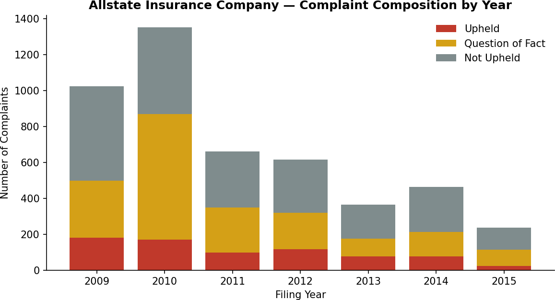

Trend of complaints over the years
Allstate's complaint volume and complaint ratio both fell sharply and fairly steadily from 2009 to 2015:

Filing Year | Premiums ($M) | Upheld | Q. of Fact | Not Upheld | Total Complaints | Ratio
2009 | 1269.438 | 180 | 318 | 525 | 1023 | 0.1418
2010 | 1194.346 | 170 | 698 | 482 | 1350 | 0.1423
2011 | 1127.18 | 97 | 251 | 312 | 660 | 0.0861
2012 | 1047.68 | 116 | 203 | 297 | 616 | 0.1107
2013 | 952.202 | 75 | 100 | 188 | 363 | 0.0788
2014 | 865.759 | 76 | 136 | 251 | 463 | 0.0878
2015 | 747.431 | 23 | 91 | 123 | 237 | 0.0308

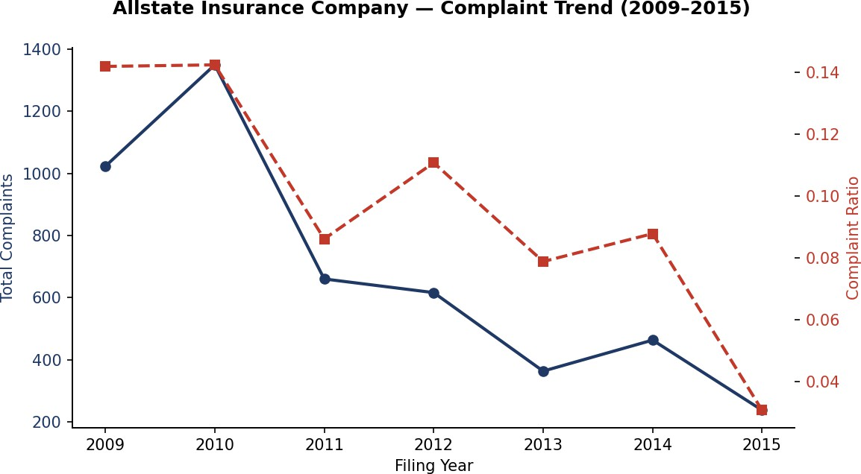

    - Total complaints fell 76.8%, from 1,023 in 2009 to 237 in 2015.
    - The complaint ratio (upheld complaints per premium dollar) fell 78.3%, from 0.1418 to 0.0308.
    - 2010 was the worst year (1,350 complaints, ratio 0.1423), coinciding with a spike in Question-of-Fact cases (698, more than double any other year) — consistent with a period of disputed claims handling, likely tied to broader no-fault claims volatility in the NY market in that period.
    - From 2011 onward the decline is fairly consistent, with a temporary uptick in 2012 (616 complaints, ratio 0.1107) before resuming its decline.
    - DFS's own comparative rank for Allstate moved only slightly (119th in 2009 to 115th in 2015 among all filers), which shows peer insurers were improving their ratios over the same period too — Allstate's gains were roughly in line with, not dramatically ahead of, the broader market.

Improvement recommendation
Allstate Insurance Company is the suggested candidate for further improvement, notwithstanding its strong multi-year downward trend, for two reasons: (1) its Upheld and Question-of-Fact complaint shares remain above the industry average even after the improvement, and (2) among the five benchmarked companies its 2015 complaint ratio (0.0308) is roughly 3x GEICO General's (0.0109) and more than 3x Progressive Casualty's (0.0092) on a comparable premium base. Priority areas suggested by the data: reducing Question-of-Fact volume (Allstate's largest complaint category, and its biggest gap versus the market) through clearer claims documentation and faster resolution of no-fault disputes, which historically has been the leading driver of ambiguous complaint outcomes in NY auto claims.

Progress of Premiums Over Time and Likely Causes
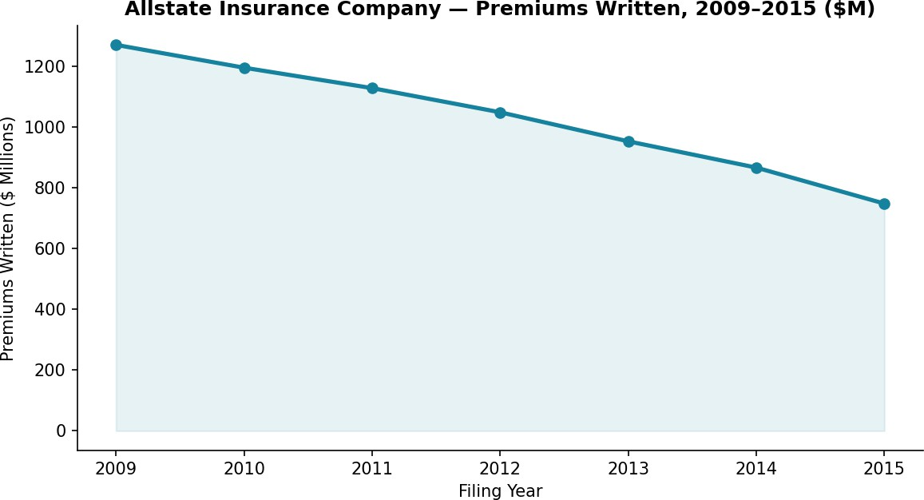
Allstate's NY premiums written fell steadily every year in the dataset, from $1,269.4M in 2009 to $747.4M in 2015
— a 41.1% decline, even as the number of policies implied by complaint volume fell faster still (76.8%), which is why the complaint ratio improved.

Likely contributing factors
    - Claims frequency / no-fault dynamics: the sharp 2009–2010 spike in Question-of-Fact complaints, followed by a steady decline, tracks the broader wave of no-fault claim disputes and fraud-related litigation that affected the NY auto market in the early 2010s; as that wave subsided, both complaints and (likely) loss costs eased.
    - Regulatory changes: NY tightened no-fault claims-handling and anti-fraud regulation over this period (including stricter verification requirements for medical/PIP claims), which plausibly reduced disputed claims industry-wide, consistent with the industry-wide complaint decline shown in Section 4.
    - Market/competitive shifts: the steady premium decline, even as New York auto insurance overall grew, suggests Allstate lost market share in NY over this period — plausibly to lower-priced direct writers (GEICO, Progressive) that gained share nationally over the same years.
    - Economic conditions: the 2009–2011 window overlaps the aftermath of the 2008 recession, when reduced driving and vehicle purchases nationally softened auto insurance demand and pricing.

Outlook
If Allstate's premium and complaint trends continue on their historical trajectories, the data points to continued gradual premium erosion in the New York book alongside continued improvement in complaint ratio — i.e., a smaller but better-performing NY book, assuming no reversal in the market-share trend. Because the 2016 record duplicates 2015 in this dataset, that year cannot confirm whether the decline continued, flattened, or reversed; refreshed DFS filings would be needed to extend the trend with confidence.

Five-Company Comparison Dashboard
Allstate is benchmarked here against four peers with full 2009–2015 NY filings: GEICO General Insurance Company, State Farm Mutual Automobile Insurance Company, Progressive Casualty Insurance Company, and Liberty Mutual Fire Insurance Company.
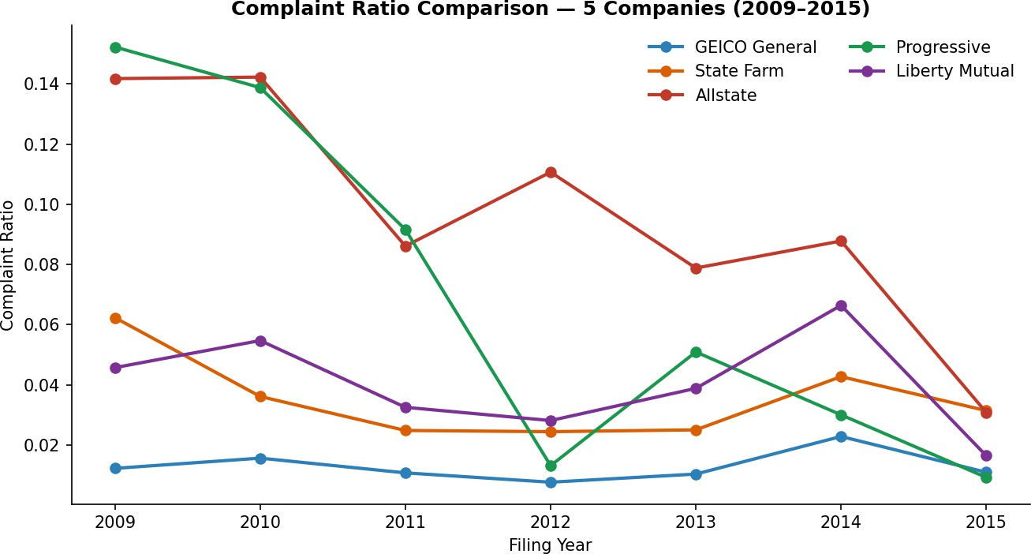
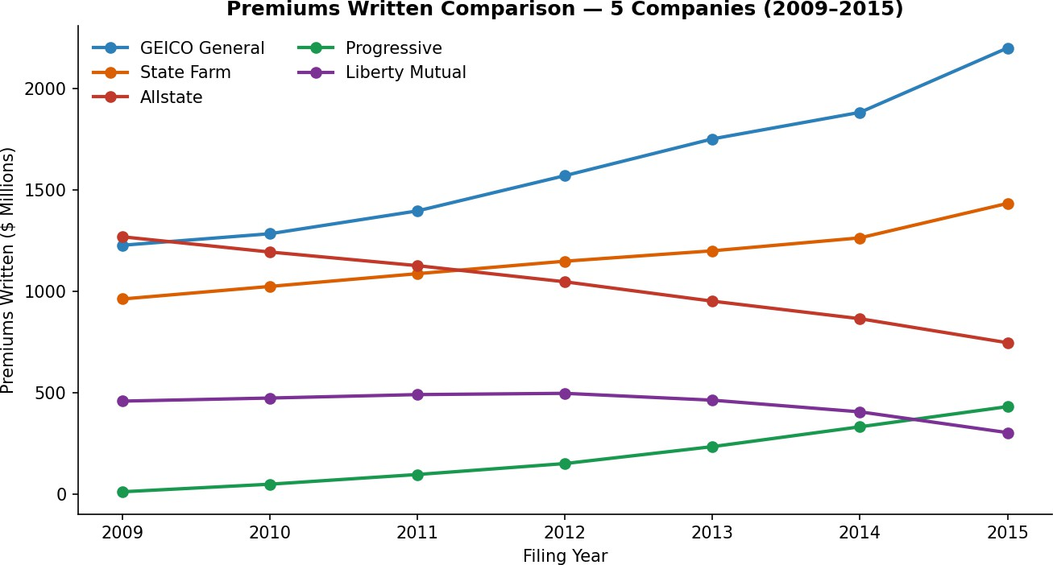

2015 snapshot:

Company | Complaint Ratio | Total Complaints | Premiums ($M) | DFS Rank
GEICO General | 0.0109 | 503 | 2199.89 | 96
State Farm | 0.0314 | 221 | 1434.015 | 116
Allstate | 0.0308 | 237 | 747.431 | 115
Progressive | 0.0092 | 96 | 432.722 | 94

Liberty Mutual | 0.0164 | 56 | 304.589 | 101

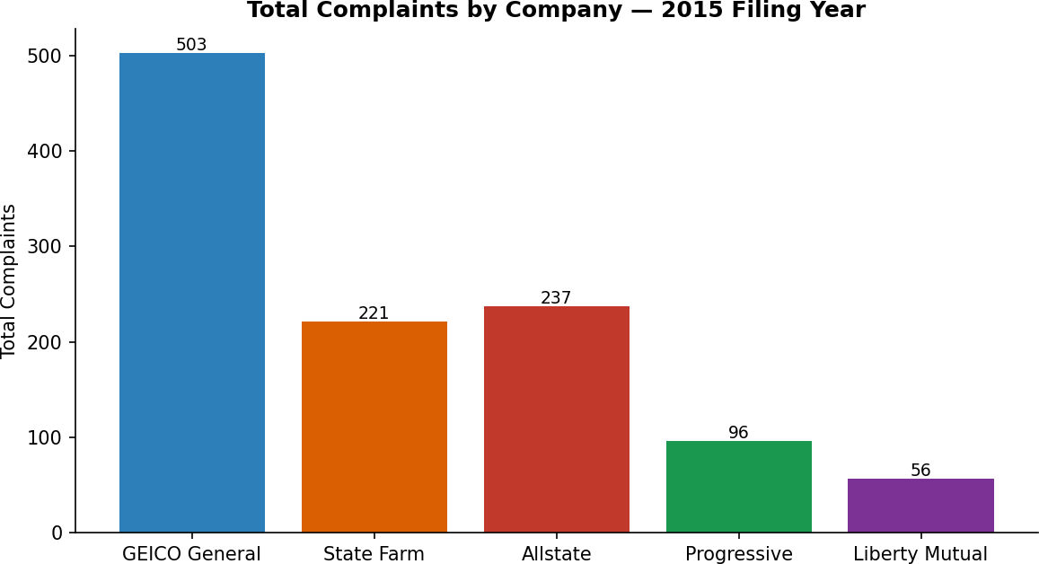

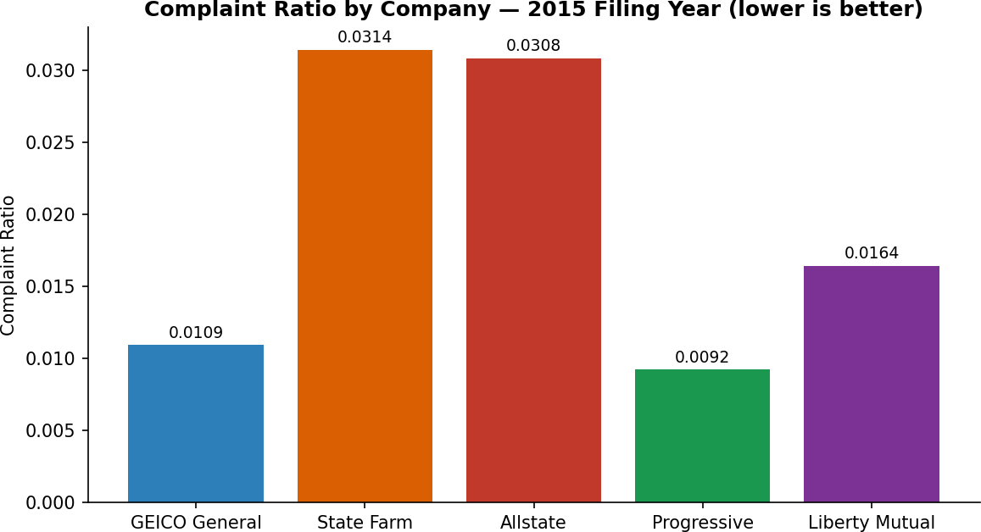

- Progressive Casualty and GEICO General post the lowest complaint ratios of the group (0.0092 and 0.0109) despite carrying large or mid-sized premium bases, indicating the strongest complaint-to-scale performance.
- Allstate and State Farm sit close together at the higher end (0.0308 and 0.0314) — both roughly 3x GEICO's ratio.
- Liberty Mutual sits in the middle (0.0164) with the smallest premium base of the five, giving it comparatively little room for complaint volume to be diluted by scale.
- All five companies trended downward in complaint ratio from 2009 to 2015, indicating the improvement is partly a market-wide effect (see Section 3.1) rather than unique to any one insurer.

Summary

Across 2009–2015, Allstate's New York auto complaint experience improved substantially in absolute and ratio terms, in step with a broader industry-wide decline in complaints likely tied to regulatory tightening of no-fault claims handling. Allstate's premium base contracted over the same period, suggesting the improvement came alongside a shrinking book rather than being purely a service-quality gain. Relative to peers, Allstate's 2015 complaint ratio remains above GEICO's and Progressive's, with Question-of-Fact complaints as its clearest area for continued improvement.

